

The Air Ambulance White Peak Challenge
Friday 15th May – Sunday 17th May 2015

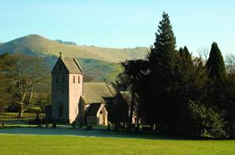
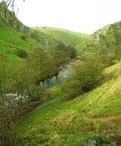
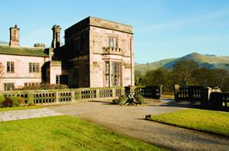
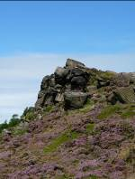
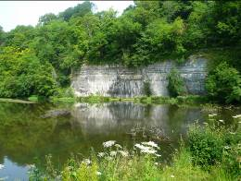

1. The White Peak Challenge!
The White Peak Challenge is a 24 mile walk through 7 of the most beautiful Dales in the Peak District National Park. Our challenge begins on the outskirts of Buxton and makes its way through Wye Dale, Millers Dale, Monsal Dale, Deep Dale, Lathkilldale, Bradford dale to Darley Dale. Along the way we pass through some numerous nature reserves, see some the finest scenery in the country and visit some of the most picturesque villages, which needless to say come complete with some fine traditional inns and cafes

Day 1: Saturday Wye Dale, Millers Dale, Monsal Dale and Monyash
We start this lovely day by descending into the beautiful valley of Wye dale. Initially our footpath follows the old disused railway line as it wends its way along the meandering valley. This is a lovely start not just because of the delightful scenery, but also because it’s a broad and sociable path which will allow us all to chat and get to know each other. Soon we cross to the riverside path which follows the tumbling waters of the Wye into Millers Dale. These beautiful dales are predominantly limestone with their towering white cliffs and rich nature reserves. The waters are sparklingly clear and they are home to a wealth of wildlife including a colourful flora. Amongst this lies a working history of old mills, weirs and numerous mill pools which are now a haven for wildfowl. Good tracks continue to weave their way through these dales to Monsal Head, where we might grab an ice cream or a light refreshment whilst we drink in the views. Now we begin the final section of the trek through Lower Monsal Dale, into Deepdale and over the open farmlands to Monyash.

Distance 12 miles (19km) Ascent 1000ft (340m) of a few shorter climbs

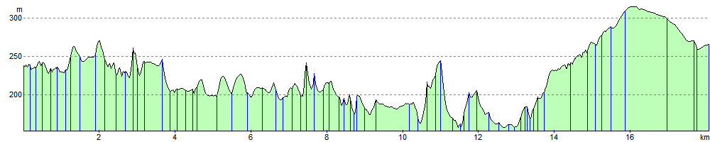
Day 2: Sunday Lathkilldale, Bradford dale, Robin Hoods Stride and Darley Dale
Alighting at Monyash where we concluded yesterdays walk, we begin the day by walking down into the beautiful Lathkilldale. Here a gently babbling brook leads us down as the valley deepens. There are cataracts, lakes, waterfalls, trout pools, pack horse bridges, old mine works adorned with creepers as nature reclaims its own. Emerging from the bottom of the valley we then head up another beautiful valley the wonderful Bradford dale. After this its over to Robin Hoods Stride, here a towering sandstone escarpement breaks through the rolling countryside and a huge rocky tor crowns its summit. A short scramble leads us up to the top where your efforts are rewarded with a breath-taking panorama over the surrounding countryside. From here, we cross the vale to the lovely village of Birchover, where we may visit a local hostelry! However the end of our challenge is calling and we force ourselves onwards to Darley Dale and the end of our trek.
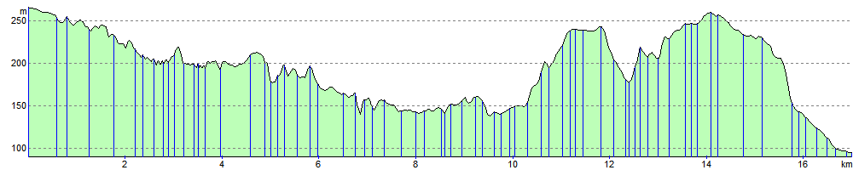
12 miles (19km) with 1,400ft (450m) of ascent

Congratulations!!!
2. Accommodation and What’s Included In The Price!

Makeney Hall Hotel is a magnificent Victorian country mansion, situated on the heart of Derbyshire It is set in six acres of beautifully landscaped gardens with breathtaking views across the Amber Valley. Only eight miles from Derby and two miles from the flourishing market town of Belper, the hotel enjoys the most tranquil surroundings. The grandeur of the hotel setting combines with the warmth and attentiveness of our staff to make each guest feel at home and really special. From the informal cocktail bar to the elegant oak panelled dining room with an impressive oak fireplace, you’ll find daily and a la carte menus to tempt you wherever you prefer to dine. Needless to say all of the 45 bedrooms are decorated in a warm traditional style in keeping the hotel’s heritage. All in all, this makes an ideal base for our Challenge!

Friday Night
We will aim to start the event by meeting everyone in the bar on the Friday night at 7pm. You will have the chance to meet your fellow participants and make some new friends. Dinner will then be served in the restaurant at 8pm. We appreciate that a lot of you will have had long journeys down and it may not be possible to make the 7pm meet. After dinner we’ll have brief chat about the event and then relax and enjoy the evening.

Arrival Meal: 8.00 pm
Breifing after meal.

Saturday
Breakfast: 8am
Leave by coach to start the Challenge: 9:15am
Picnic lunch
Three course dinner: 7.30pm

Sunday
Breakfast: 8am
Leave by coach: 9am

Picnic lunch
Friday 15th May – Sunday 17th May 2015 | Price per person
Full Package  With 2 nights accommodation  2 breakfasts  2 picnic lunches  2 evening meals  All transport to walks  Professional walking guides | twin share £169.00 per person  single £199.00 per person  (Maximum no. 50)
Event only  2 picnic lunches  1 evening meal  All transport to walks  Professional walking guides | £75.00

3. Joining Instructions to Makeney Hall

On behalf of all the WalkWise team, thank you for booking your walking event! The WalkWise guides will arrive early evening and are looking forward to meeting you.

- Arrival time: any time after 4pm. Should you wish to arrive any earlier please enquire at the centre directly.
- Arrival meal: is set for 8pm when you will have the opportunity to meet your guides and they will discuss the overall event and walks.
(If you are going to be late for the arrival dinner please advise the hotel or leaders on the contact numbers below!)
- What to bring: To ensure that you are properly equipped, please take a moment to read through the ‘What to bring list’ and ensure that you have the necessary clothing and equipment.

Directions: Makeney Hall Hotel, Makeney, Milford, Belper, Derbyshire, DE56 0RS Tel: 01629 583 454

By car From the north
Leave the M1 at J28. at J28. Follow the signs to Matlock along the A38. Turn off at the A610, signposted Ambergate. Turn right at the A6, following signs for Matlock. Stay on the A6 heading for Derby and as you are coming into Milford look out for the King William pub on the left. (if you go over the bridge and into Milford you have just gone too far!) Turn left into Makeney Road. Follow Makeney for about 0.5miles to turn right into the large entrance for Makeney Hall.

From the south
Leave the M1 at junction 25, then at roundabout take the 1st exit, then merge onto the A52 Signed Derby A61. At Pentagon Island roundabout take the 3rd exit onto the A61 signed Chesterfield A61. After 1 mile at roundabout take the 3rd exit onto the A61, After 0.6 miles at roundabout take the 2nd exit onto the A61signed Chesterfield. After 0.3 miles at roundabout take the 3rd exit onto the A61. After 0.5 miles at the Little Eaton roundabout take the 1st exit onto the A38 ring Road. In 0.8 miles branch left signed A6, and then at roundabout take the 4th exit onto the A6 signed Matlock. After 4 miles in Milford go over the bridge at the end of the bridge at the King William Pub turn right into Makeney Road. Follow Makeney for about 0.5miles to turn right into the large entrance for Makeney Hall.

Travel by train
Overall travel contacts http://www.travelline.org.uk 0871 200 22 33

Train Information http://nationalrail.com 08457 48 49 50

By Train:
The nearest railway station is Duffield (1.6 miles around 5 mins by taxi)
London via Derby and takes just over 2.0 hrs

By Taxi:
- Little Eaton Cars (01332) 880 993
- Belper Cars (01773) 828 384
- BTS Belper 07977 600 600

Peak District National Park Visitor Centre Belper - 01773880474 info@belpernorthmill.org.uk

If you are having problems finding the centre, please call them directly, or you could call one of the guides:
Andrew Wilkinson: 0784 172 1263
Andrew Casey: 0774 894 2263
Gideon Wheater: 0780 907 0257

Whilst every effort has been taken to ensure your trip is enjoyable, occasionally unforeseen difficulties may arise. Should you have any concerns please raise them with your WalkWise guides at the time. They will then endeavour to resolve them swiftly so that you can enjoy your trip.

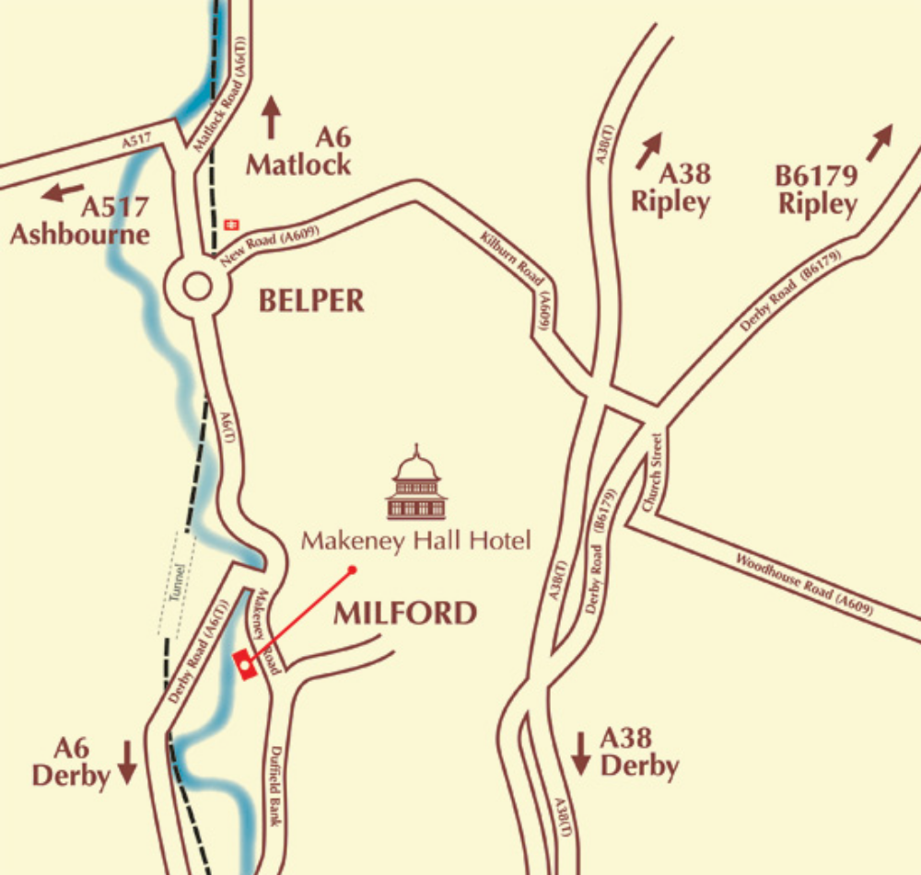
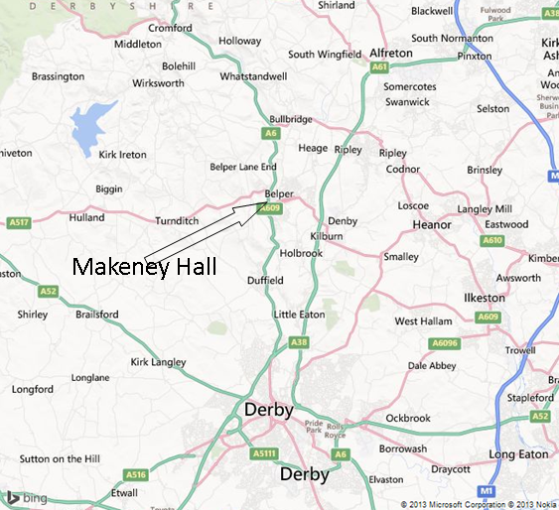

Maps: If you would like a map for this event, reduced prices are available by going to www.walkwise.co.uk, and clicking on the Aqua3 Map Deal button. This will take you to the Aqua3 website, from where you can order.
The map(s) for this event are:
1:25000: Explorer: EX024: Peak District White Peak
1:25000: Explorer: EX 259: Derby

What to bring:
You MUST have:
- Walking boots
- A Water bottle (minimum 1 litre)
- A Rucksack with a plastic liner
- Waterproofs: jacket and trousers
- A Warm hat
- Warm gloves (not leather)
- Thick walking socks
- Base layer: (thin thermal or warm T-shirt. Best not to be cotton as it gets cold when wet)
- Over layer: (warm sweater or fleece)
- Extra layer: warm top for when cold (eg. when stopped for lunch)
- Comfortable walking trousers (not jeans as they are too cold & heavy when wet)
- Personal Medication
- Smart casual clothes for the evening.

You may wish to bring:
- Vacuum flask (if you like hot drinks on the hill)
- Medium size Tupperware container or plastic bag, to put picnic lunch in.
- Sit mat
- Sun glasses
- Lip salve
- Camera
- Personal first aid kit
- Trekking Poles

In good weather and/or summer, you may also wish to bring
- Short trousers
- T - Shirts
- Sun hat
- Sun tan lotion

In poor weather and/or winter, you may also wish to bring:
- Gaiters
- Extra warm clothing

5. Preparing yourself for the Event

The Peak District Challenge a physically demanding event. You will be walking along the coast for two days and each of these days will consist of up to 13 miles with a considerable amount of ascent and descent as well. If you are not used to walking, or taking regular exercise, then you ought to prepare yourself.

Your body needs breaking in and occasional maintenance too! If you prepare yourself gradually you will enjoy the event even more. It is best, less painful and much easier to build up your fitness levels gradually! If you exercise regularly, go swimming, play squash once a week or consider yourself to be averagely fit already, then you have a good starting point, but it is best get used to walking as well. Following these guidelines will help your body prepare for the event:

Getting used to your Boots!
Simply walking around your home and going shopping in your boots will allow your feet to get used to them. This will help to prevent unnecessary blisters and pain, almost always a good thing! Nevertheless, this is not sufficient, it is useful to prepare yourself a little bit more, and the best way to do this is to walk!

Building up your Fitness
The simplest changes in your everyday life can make the biggest difference.
- If you are popping out to the shops, then slip into your boots and walk instead of taking the car.
- If you go to work on the bus or tube, make a resolution to walk to the next stop or get off a stop early.
- Once a week during your lunch hour take a brisk walk around the park.
- To get yourself used to ascent and descent, make a resolution not to use the lift! Using the stairs regularly is a very effective tool in preparing your body for climbing in the hills.

Go on some half day walks
To build up your stamina, it is a good idea to actually go on a walk! On a couple of days off, have a walk in the park or go the local countryside. Buy a local guide book of short walks, perhaps get some friends together and just do it! Walks which end with a pub lunch seem to be extremely popular!
Try to do 2 or 3 half-day walks over the next few months and gradually build up the distance you do.

Try some full day walks
After doing some half-day walks, try a couple of full day walks. Keep increasing the distance until you feel happy with your own ability.

This is the best and most effective way to prepare yourself for the event.
Remember the event is not a flat out race, it is fun challenge event
and a good fitness level will help you to get the most out of it!
6. How to Book and Summary of Booking Conditions

- Any provisional booking will be held for 14 days pending receipt of your deposit.
(the deposit of £50.00 is non refundable). If we do not receive your payment within the 14 days after submitting your application your place will be released

- Your place is secured only when WalkWise UK Ltd receive your deposit

- Payment By Cheque: Please make out all cheques to Walkwise UK Ltd Trust Account , remembering put your name and trek on the back of the cheque and then send them to:
Walkwise UK Ltd
30 Greenways Drive
Endmoor
Kendal
LA8 0EL

Bank transfer
Alternatively, you can pay directly into Walkwise Account, Please add your name and trek in the reference section
Trust account: Walkwise UK Ltd Trust Account
Sort code: 01-09-75
Account no: 81234228

- The balance must be received 8 weeks prior to the start date of the event

- Cancellation
Up to 8 weeks prior to the event, you cancellation will result in loss of deposit. Thereafter the following cancellation charges will apply.
cancellation up to 6 weeks prior 50% of the price
cancellation up to 3 weeks prior 75% of the price
cancellation up to 2 weeks prior 100% of the price.

- The event will be operated by WalkWise UK Ltd.

- For complete Booking conditions please see
http://www.walkwise.co.uk/terms-and-conditions.html

8) Their company address is
WalkWise UK Ltd
30 GreenWays Drive Endmoor Kendal LA8 0EL
Tel Fax 01539 560 911
e-mail : holidays@walkwise.co.uk
www.walkwise.co.uk

.

7. Insurance
The most comprehensive insurance policy that seems to be available at a sensible cost is via the post office. We recommend that every participant takes out insurance, but with such competitive rates on the high street it is best to pick up it individually.

8. Other Useful Info

Other Useful Info:

- www.walkwise.co.uk

- Walkwise Tel: 01539 560 911 Email: holidays@walkwise.co.uk

- Air Ambulance?????

