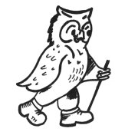
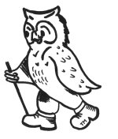
WalkWise Joining Instructions
Arundel West Sussex and South Downs

The Hilton Avisford Park, Arundel

On behalf of all the WalkWise team, thank you for booking your walking event! The WalkWise guides will arrive early evening and are looking forward to meeting you.

- Arrival meal: is set for 08:00 pm when you will have the opportunity to meet your guides and they will discuss the overall event and walks.
( If you are going to be late for the arrival dinner please advise the hotel or leaders on the contact numbers below!)
- Arrival time: any time after 04:00 pm. Should you wish to arrive any earlier please enquire at the centre directly.
- What to bring: To ensure that you are properly equipped, please take a moment to read through the ‘What to bring list’ and ensure that you have the necessary clothing and equipment.
- The maps for this weekend are 1: 25 000.
EX121 – Arundel & Pulborough

If you are not going to make the dinner at 8pm please ensure you contact WalkWise or the hotel on the numbers below.

Hotel Tel: 01243 558 300

Address: Hilton Avisford Park, Arundel, Yapton Lane, Walberton, Arundel, BN18 0LS
Andrew Casey: 0774 894 2263
Gideon Wheater: 0780 907 0257

Whilst every effort has been taken to ensure your trip is enjoyable, occasionally unforeseen difficulties may arise. Should you have any concerns please raise them with your guides at the time. They will then endeavour to resolve them swiftly so that you can enjoy your trip.

Overall travel contacts http://www.travelline.org.uk 0871 200 22 33

Train: http://nationalrail.com 08457 48 49 50

By train:
You can get direct trains to Arundel Railway Station or Barmham Station, however on some occasions you may have to change trains it may be best to check before you depart. Once you get to the station please call the hotel reception 01243 558 300 and they will book you a taxi or call

Arundel, Castle Cars Taxi, 01903 884 444
Arundel Tourist information: 01903 882268
www.arundel.org.uk/tourist.html

Directions: By car
Take the ring road north, then the M23 signposted to Crawley and Brighton.
Exit the M23 at Junction 11 and go onto the A23. At the roundabout take A272 exit (Cowfold Road) and continue along it (Station Road), taking the left turn to A24 (Worthing).
Exit at the roundabout at the A280 (Long Furlong). Take the 2nd exit at the roundabout then 3rd exit off the next roundabout onto the A27 (Arundel Road). Turn left into Yapton Lane to find the Hilton Avisford Park hotel.

From Heathrow Airport, turn left onto Stirling Road then turn right onto Southern Perimeter Road (Hounslow). Continue on Southern Perimeter Road (Staines), taking the 2nd exit on to the A3113 (signposted Dachet, M25). Turn off at the roundabout onto M25 and at leave at junction 9. At the roundabout take the 3rd exit onto the A243. At roundabout take the 3rd exit and continue onto the A243. At Knoll Roundabout, take the 2nd exit onto the A24 (signposted Dorking) and continue on the A24 until you come to a roundabout with signposts for A280, (Littlehampton, Chichester, Portsmouth).
Follow the A280 until you come to signs for the A27. At roundabout merge with the A27.
Exit the roundabout at the A27 (Arundel Road) and turn right into Yapton Lane to find the Hilton Avisford Park hotel.

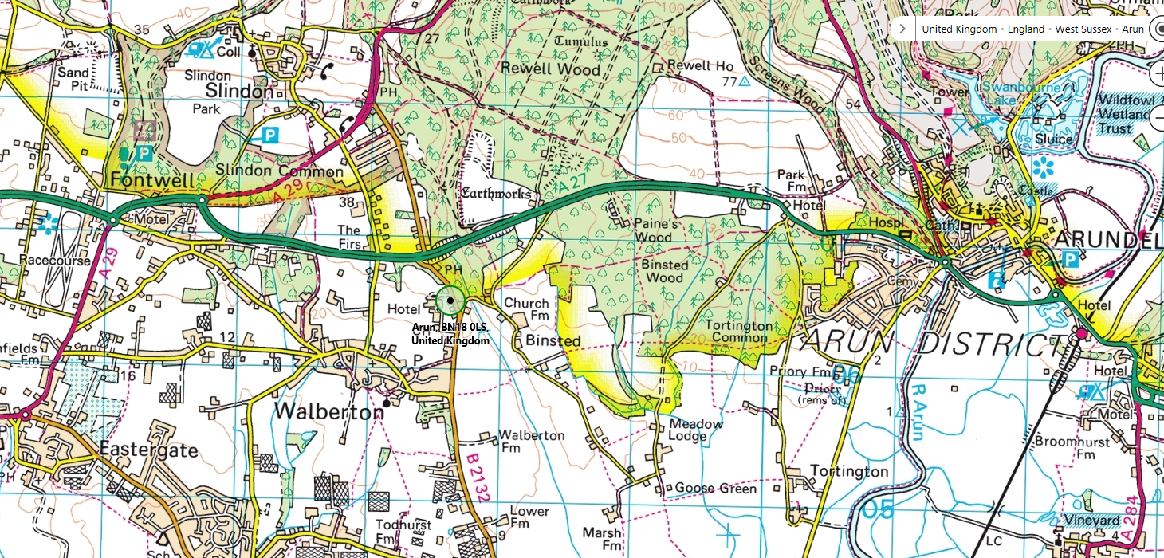

What to bring:
You MUST have:
- Walking boots
- A Water bottle (minimum 1 litre)
- A Rucksack with a plastic liner
- Waterproofs: jacket and trousers
- A Warm hat
- Warm gloves (not leather)
- Thick walking socks
- Base layer: (thin thermal or warm T-shirt. Best not to be cotton as it gets cold when wet)
- Over layer: (warm sweater or fleece)
- Extra layer: warm top for when cold (eg. when stopped for lunch)
- Comfortable walking trousers (not jeans as they are too cold & heavy when wet)
- Personal Medication
- Smart casual clothes for the evening.

You may wish to bring:
- Trekking Poles
- Vacuum flask (if you like hot drinks on the hill)
- Medium size Tupperware container or plastic bag, to put picnic lunch in.
- Sit mat
- Sun glasses
- Lip salve
- Camera
- Personal first aid kit

In good weather and/or summer, you may also wish to bring
- Short trousers
- T - Shirts
- Sun hat
- Sun tan lotion

In poor weather and/or winter, you may also wish to bring:
- Gaiters
- Extra warm clothing

