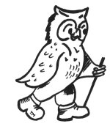
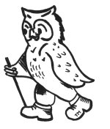
Walking Weekend Eastbourne, Sussex Downs & Coast
Joining Instructions to the Lansdowne Hotel

On behalf of all the WalkWise team, thank you for booking your walking event! The WalkWise guides will arrive early evening and are looking forward to meeting you.

- Arrival meal: is set for 08:00 pm when you will have the opportunity to meet your guides and they will discuss the overall event and walks.
( If you are going to be late for the arrival dinner please advise the hotel or leaders on the contact numbers below!)
- Arrival time: any time after 04:00 pm. Should you wish to arrive any earlier please enquire at the centre directly.
- What to bring: To ensure that you are properly equipped, please take a moment to read through the ‘What to bring list’ and ensure that you have the necessary clothing and equipment.

Address: Lansdowne Hotel, King Edward’s Parade, Eastbourne, East Sussex, BN21 4EE
Telephone: 01323 725174

Gideon: 0780 907 0257
Andy: 0774 894 2263

Whilst every effort has been taken to ensure your trip is enjoyable, occasionally unforeseen difficulties may arise. Should you have any concerns please raise them with your guides at the time. They will then endeavour to resolve them swiftly so that you can enjoy your trip.

Maps: The map(s) for this event are:
1:25000: Explorer 123 The South Downs Way, Eastbourne and Beachy Head

Directions:
The Best Western Lansdowne Hotel is located on Kind Edwards Parade on the seafront in one of the best locations possible, overlooking the gardens! The hotel is located on the front no more than a 10 minute walk away from the theatres, cinema, town centre, bandstand, seafront, wish tower, restaurants and bars.

Parking is available along the seafront, which is pay and display £4.00 all day (2013). The hotel have a limited number of parking bays available, please contact them in advance to secure a space. Please note that these are issued on a first come first served basis.

Eastbourne is approximately 60miles from London

From M25 Junction 6 , take the A22 for 10 miles to pass through East Grinstead. Continue on for a further 14 miles to bypass Uckfield. Still on the A22 drive for another 13 miles to the massive roundabout at Polegate where it meets the A27. Now take the 1st exit onto the A27 (signposted Eastbourne). After 1.7 miles at the roundabout take the 2nd exit onto A22 (signposted Eastbourne). After only 0.15 miles at roundabout take the 2nd exit onto the A22. After 1.6 miles at the Shine Water roundabout take the 2nd exit on to Highfield Link A22 (signposted Town Centre). After 0.4 miles at Lottbridge roundabout take the 1st exit onto Lottbridge Drove. Entering Eastbourne. After 0.8 miles at the Birch roundabout take the 2nd exit onto Lottbridge Drove. After 0.1 miles at the Seaside roundabout take the 3rd exit onto Seaside A259 (signposted Town Centre). After 0.8 miles at traffic signals turn left onto Beamsley Road. After 0.15 miles turn right onto Royal Parade. After 0.2 miles If you reach the pier. The Royal Parade now turns into the Grand Parade continue on for a further 600m and look out on your Right for King Edward statue and turn right into Wilmington Square. If you reach the Grand Hotel you have gone too far!

By train:
Trains leave London Victoria every 30minutes. Tel 08457 48 49 50
The Train Station is 10-15 minutes walk depending on your stride and amount of luggage!!

Tourist information: Eastbourne (01323) 411400
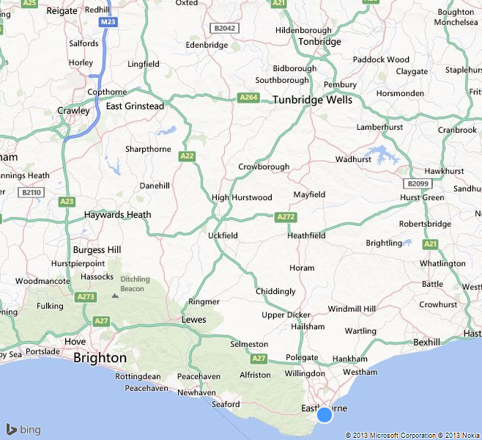

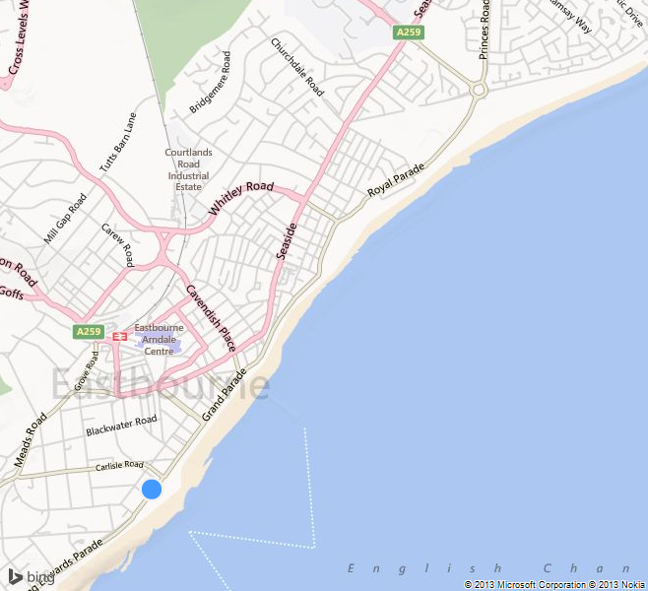

What to bring:
You MUST have:
- Walking boots
- A Water bottle (minimum 1 litre)
- A Rucksack with a plastic liner
- Waterproofs: jacket and trousers
- A Warm hat
- Warm gloves (not leather)
- Thick walking socks
- Base layer: (thin thermal or warm T-shirt. Best not to be cotton as it gets cold when wet)
- Over layer: (warm sweater or fleece)
- Extra layer: warm top for when cold (eg. when stopped for lunch)
- Comfortable walking trousers (not jeans as they are too cold & heavy when wet)
- Personal Medication
- Smart casual clothes for the evening.

You may wish to bring:
- Vacuum flask (if you like hot drinks on the hill)
- Medium size Tupperware container or plastic bag, to put picnic lunch in.
- Sit mat
- Sun glasses
- Lip salve
- Camera
- Personal first aid kit
- Trekking poles

In good weather and/or summer, you may also wish to bring
- Short trousers
- T - Shirts
- Sun hat
- Sun tan lotion

In poor weather and/or winter, you may also wish to bring:
- Gaiters
- Extra warm clothing

