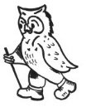
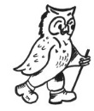

WalkWise Joining Instructions to

On behalf of all the WalkWise team, thank you for booking your walking event! The WalkWise guides will arrive early evening and are looking forward to meeting you.

- Arrival meal: is set for 08:00 pm when you will have the opportunity to meet your guides and they will discuss the overall event and walks.
( If you are going to be late for the arrival dinner please advise the hotel or leaders on the contact numbers below!)
- Arrival time: any time after 04:00 pm. Should you wish to arrive any earlier please enquire at the centre directly.
- What to bring: To ensure that you are properly equipped, please take a moment to read through the ‘What to bring list’ and ensure that you have the necessary clothing and equipment.

If you are not going to make the dinner at 8pm please ensure you contact WalkWise or the hotel on the numbers below. If you are having difficulties in finding the hotel or area going to arrive late please inform the Hotel directly:

Tel: 01680 812544
Isle of Mull Hotel & Spa, Craignure, Isle of Mull, Scotland PA65 6BB
Or call
Gideon: 0780 907 0257
Andy: 0774 894 2263

Killin Hotel, Highland Perthshire

Centre Tel: 01567 820 296
Address: Killin Hotel, Killin, Perthshire, FK21 8TP
Killin Tourist Information Tel: 01567 820 254
Gideon Wheater: 0780 907 0257
Andrew Casey: 0774 894 2263

Whilst every effort has been taken to ensure your trip is enjoyable, occasionally unforeseen difficulties may arise. Should you have any concerns please raise them with your guides at the time. They will then endeavour to resolve them swiftly so that you can enjoy your trip.

How to get there:
Suggested route by car: From Sterling take the M9 to exit Junction 10. At the roundabout take the first exit signed A84. Now drive for 23 miles to meet the A85 at Lochearnhead. Keep left on the A85 towards Crianlarich and Killin. After a further 5 miles turn right onto the A827 (used be a toll road called the Lix Toll so you can ignore this now) and after 3.0 miles you will find the Killin Hotel.
Overall travel contacts http://www.travelline.org.uk 0871 200 22 33

Train: Nearest train is from Crianlarich some 12 miles away.
Taxi: Killin Kabs, 1, Pier Rd, Killin, Perthshire FK21 8TL , Tel: 01567 820 777

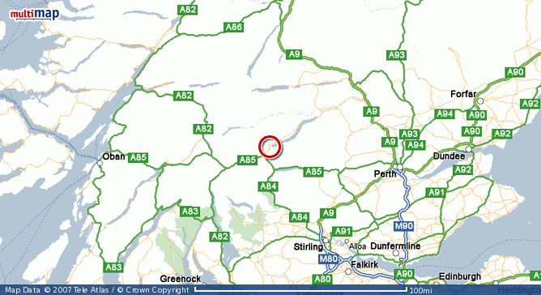
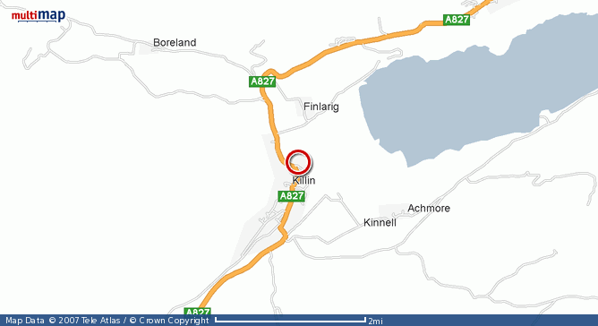
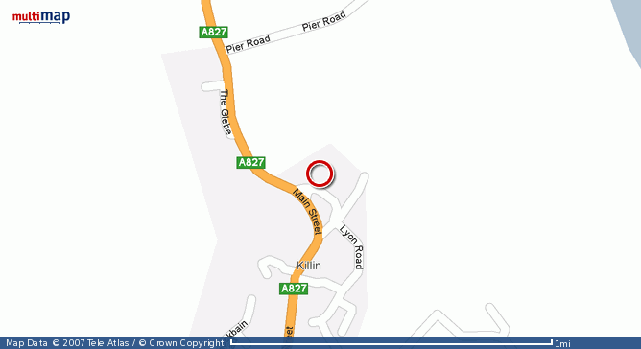
Killin Hotel
Loch Tay
Loch Tay
Killin Hotel
Killin Hotel
Overall View
Closer View
Local View

The general instructions to get to Craignure are:
From Glasgow take the A82 north to Tyndrum
From Edinburgh, the south or Stirling take the M9 to Stirling junction 10. Then Take the A84 via Calander to Lochearnhead. Continue on the A85 to Crianlarich and Tyndrum

From Tyndrum turn Left onto the A85 and follow this for 37miles to Oban. Once in Oban simply follow the signs to the passenger ferry terminal in the port.

Nb due to the small roads on the island we will need to take cars to the start of the walks, coaches can only use one main road! You may wish to car share to reduce cost and the ferry crossing. At the time of release ferry prices were not available but it was about £26.00 per car rtn in 2015.
You will need to book you place fairly early!!!

Ferry information
Caledonian Macbrayne:
General enquiries 0800 066 5000
www.caclmac.co.uk
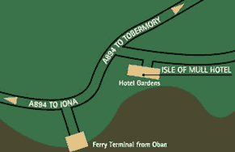
Two ferry ports service Mull. From the south, head for Oban and take the ferry to Craignure. The hotel is then just 1km along the road to Tobermory.

From the North, take the Corran and Lochaline ferries. Turn right at Fishnish toward Craignure. We are along to the left, just before reaching Craignure.

By Railway: The nearest railway station is Oban

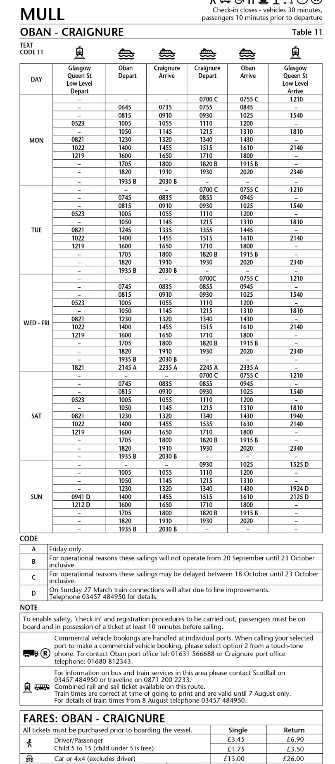
NB THIS IS THE 2016 timetable and is for example only. The new timetable is due out shortly (usually November)

What to bring:
You MUST have:
- Gaiters
- A Water bottle (minimum 1 litre)
- A Rucksack with a plastic liner
- Waterproofs: jacket and trousers
- A Warm hat
- Warm gloves (not leather)
- Thick walking socks
- Base layer: (thin thermal or warm T-shirt. Best not to be cotton as it gets cold when wet)
- Over layer: (warm sweater or fleece)
- Extra layer: warm top for when cold (eg. when stopped for lunch)
- Comfortable walking trousers (not jeans as they are too cold & heavy when wet)
- Personal Medication
- Smart casual clothes for the evening.

You may wish to bring:

Vacuum flask (if you like hot drinks on the hill)
Goggles
- Medium size Tupperware container or plastic bag, to put picnic lunch in.
- Sit mat
- Sun glasses
- Lip salve
- Camera
- Personal first aid kit
- Sun tan lotion
- Balaclava
- Extra warm clothing

