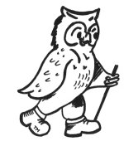
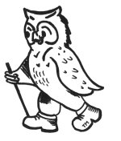
Walking Weekend NEW The Peveril of the Peaks
Joining Instructions to The Peveril of the Peak

On behalf of all the WalkWise team, thank you for booking your walking event! The WalkWise guides will arrive early evening and are looking forward to meeting you.

- Arrival time: any time after 4:00 pm. There will be tea and biscuits available in the main lounge between 4.00-4.30pm. Should you wish to arrive any earlier please enquire at the centre directly.
- Arrival meal: is set for 7:00 pm. Meet in the bar from 6:30 pm when you will have the opportunity to meet your guides and they will discuss the overall event and walks.
(There is only one sitting for the evening meal as we are fitting in with other guests. The kitchen closes at 7.30 pm and if you going to arrive after that we would advise you to eat en-route. If you are going to be late for the arrival dinner please advise the hotel or leaders on the contact numbers below!)
- What to bring: To ensure that you are properly equipped, please take a moment to read through the ‘What to bring list’ and ensure that you have the necessary clothing and equipment.

Centre Tel: (01335) 350 396
Centre Adress: The Peveril of the Peak, Thorpe, Dovedale, DE6 2AW

Travel to the Peveril of the Peak

Grid reference: SK 157 505

By car to the Peveril of the Peak Satellite navigation, enter the postcode DE6 2AW.

From the south leave the M1 at Junction 24 and head to Ashbourne via the A50 and A515. Continue north on the A515 heading towards Buxton. 1 mile north of Ashbourne turn left, signposted to Thorpe, Dovedale and Ilam. After a further 2 miles the road bends sharp left by The New Dog. The Peveril of the Peak lies ahead at the bottom of the hill. From Buxton take the A515 south towards Ashbourne. After 17 miles turn right at a crossroads following signs to Thorpe, Ilam and Dovedale. After 1 mile turn right by The New Dog pub and follow the road around the sharp left hand bend. The Peveril of the Peak lies ahead at the bottom of the hill.

From the west leave the M6 at junction 15and head via the A50, Cheadle (A521) and Oakamoor (A5417) to the A52. At the junction of the A52 and the A523 take the minor road signposted Ilam. After 1½ miles turn left and descend the hill. Cross the bridge at Ilam, turn right and follow the road up a steep hill and onwards through Dovedale and Thorpe village. The Peveril of the Peak is on the left hand side at the end of the village. Visit your holiday page on our website for a map. Car parking Parking is available in the grounds. No responsibility can be accepted for loss or damage to guests’ property or vehicles. We advise not to leave valuables in cars.

By rail The nearest railway stations to the Peveril of the Peak are Buxton or Derby. For train times and general rail enquiries call 08457 484950 (24hrs) or visit www.nationalrail.co.uk. If phoning from outside the UK call +44 (0)20 7278 5240.

Station transfer by taxi The 19 mile journey from Buxton railway station takes approximately 35 minutes; the 17 mile journey from Derby takes approximately 40 minutes. We have negotiated a preferential rate with Peak Cars for both pre-booked journeys of £30 from Derby and £30 from Buxton per taxi. They will arrange shared taxis wherever possible.
To book a transfer please phone or email: Peak Cars Tel: +44 (0)1335 370937/+44 (0)7890 811292 Email: peakcars.hognaston@gmail.com The return journey can be arranged on your behalf by the House Manager. Peak Cars is an independent operator not owned or managed by WalkWise or the centre.

Station transfer by bus From Buxton take the 442 bus service to Ashbourne, then change to the 101 bus to Thorpe village. From Derby take SW1 service to Ashbourne and then the 101 bus. Alight by the bus shelter in Thorpe village, from where it is a 500 metre walk along Wintercroft Lane to the Peveril of the Peak. Please contact Traveline on 0871 200 22 33 or visit traveline.info for details of bus times. Hotel Telephone number: 01335 350 396

If you are having problems finding the centre, please call them directly, or you could call one of these guides:
Gideon Wheater: 0780 907 0257
Andrew Casey: 0774 894 2263

Tourist Info: http://www.visitpeakdistrict.com/

Whilst every effort has been taken to ensure your trip is enjoyable, occasionally unforeseen difficulties may arise. Should you have any concerns please raise them with your guides at the time. They will then endeavour to resolve them swiftly so that you can enjoy your trip.

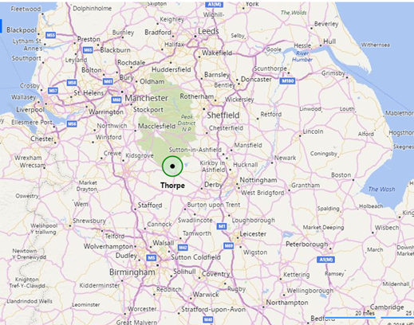

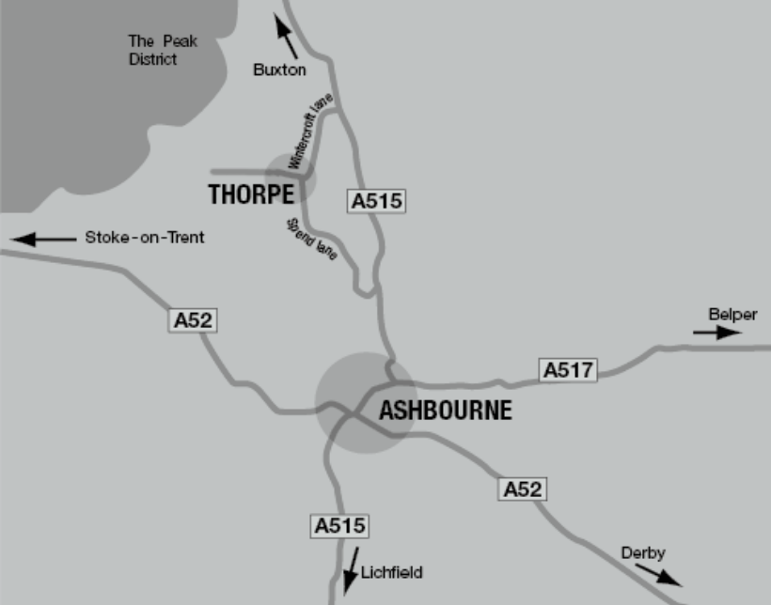
The Peveril of the Peak Hotel

What to bring:
You MUST have:
- Walking boots
- A Water bottle (minimum 1 litre)
- A Rucksack with a plastic liner
- Waterproofs: jacket and trousers
- A Warm hat
- Warm gloves (not leather)
- Thick walking socks
- Base layer: (thin thermal or warm T-shirt. Best not to be cotton as it gets cold when wet)
- Over layer: (warm sweater or fleece)
- Extra layer: warm top for when cold (eg. when stopped for lunch)
- Comfortable walking trousers (not jeans as they are too cold & heavy when wet)
- Personal Medication
- Smart casual clothes for the evening.

You may wish to bring:
- Vacuum flask (if you like hot drinks on the hill)
- Medium size Tupperware container or plastic bag, to put picnic lunch in.
- Sit mat
- Sun glasses
- Lip salve
- Camera
- Personal first aid kit
- Trekking Poles

In good weather and/or summer, you may also wish to bring
- Short trousers
- T - Shirts
- Sun hat
- Sun tan lotion

In poor weather and/or winter, you may also wish to bring:
- Gaiters
- Balaclava
Extra warm clothing

Maps:
The map(s) for this event are: 1:25000: Explorer: OL024: Peak District White Peak Area:

