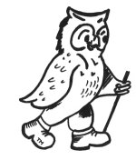
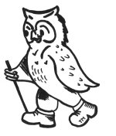

Walking Weekend Keswick Derwent and Bassenthwaite

Joining Instructions to Derwent Bank, Portinscale

On behalf of all the WalkWise team, thank you for booking your walking event! The WalkWise guides will arrive early evening and are looking forward to meeting you.

- Arrival time: any time after 4:00 pm. There will be tea and biscuits available in the main lounge between 4.00-4.30pm. Should you wish to arrive any earlier please enquire at the centre directly.
- Arrival meal: is set for 7:00 pm. Meet in the bar from 6:30 pm when you will have the opportunity to meet your guides and they will discuss the overall event and walks.
(There is only one sitting for the evening meal as we are fitting in with other guests. The kitchen closes at 7.30 pm and if you going to arrive after that we would advise you to eat en-route. If you are going to be late for the arrival dinner please advise the hotel or leaders on the contact numbers below!)
- What to bring: To ensure that you are properly equipped, please take a moment to read through the ‘What to bring list’ and ensure that you have the necessary clothing and equipment.
- We recommended these maps for this event:
1:25 000: EX004: Ordnance Survey Explorer Lake District Map- English Lakes NW Area
1:25 000: EX005: Ordnance Survey Explorer Lake District Map- English Lakes NE Area

HF Holiday’s, Derwent Bank, Portinscale, Nr Keswick, Cumbria, CA12 5TY

Tel: +44 (0)17687 73667 Fax: +44 (0)17687 71375 Email: derwentwater@hfholidays.co.uk

Directions:

For Sat Nav. Enter the postcode CA12 5TY and town Portinscale if required. Grid reference: NY 252 229

By Car:
Take the M6 to Junction 40. Follow signs for the A66, Keswick and Workington.

For those with satellite navigation, enter the postcode CA12 5TY and town Portinscale if required. From Penrith: take the A66 towards Cockermouth. One mile beyond the roundabout to Keswick and 200 yards beyond the B5289 turning, turn left off the A66 signposted to Portinscale, Grange and the Newlands Valley. Derwent Bank (not Derwentwater Hotel) is approx. ½ a mile along this road on the left after the Derwentwater Marina and before Nicol End Marina. Look out for our sign.

From Kendal: take the A591 to Keswick. To avoid the town centre turn right following signs to the A66 and Cockermouth, then follow the directions as above.

NB:If you get to the Nichol End marina you have just gone a bit too far.

By Rail
The nearest train station to Derwent Bank is at Penrith. For train times and general rail enquiries visit www.nationalrail.co.uk or call 03457 484950. If you are phoning from outside the UK call +44 20 7278 5240.

The 20 mile journey from Penrith Station takes approximately 40 minutes.

Station transfers
The centre offers a reduced price transfer between Penrith railway station and Derwent Bank every Friday and Monday. The pickup is at 4.50pm from Penrith railway station. On departure day the transfer will get you back to Penrith station by 9.50am. The transfer is £10 return, but a place must be reserved in advance by calling HF Holiday Holiday Services team on 020 8732 1220.

Station transfer by taxi
If you can’t meet our station transfer, you can arrange your own taxi. We have negotiated a preferential rate with Davies Taxis for all pre-booked journeys of £30 per taxi. (Please note - taxis that are not pre booked can be considerably more expensive at Penrith railway station). They will arrange shared taxis wherever possible. To book a transfer please phone or email: Davies Taxis Tel: +44 (0)17687 72676 Email: info@daviestaxis.co.uk

Station transfer by bus.
The X50 bus runs approximately every hour from Penrith railway station to Portinscale. From the main road take the left turn (signposted to the Newlands Valley); follow the road through the village of Portinscale. Derwent Bank is approximately ½ mile along this road after the Derwentwater Marina. Look out for our sign. Alternatively alight in Keswick and complete the final 2 miles of your journey by taxi. You can pre-book with Davies Taxis at the preferential rate of £5 per taxi.
Please contact Traveline on 0871 200 22 33 or visit www.traveline.info for details of bus times.

The return journey can be arranged on your behalf by the House manager.

DaviesTaxis is not owned or managed by HF Holidays.

If you are having problems finding the centre, please call them directly, or you could call one of the WalkWise guides.
Andrew Casey: 0774 894 2263
Gideon: 0780 907 0257

Whilst every effort has been taken to ensure your trip is enjoyable, occasionally unforeseen difficulties may arise. Should you have any concerns please raise them with your guides at the time. They will then endeavour to resolve them swiftly so that you can enjoy your trip.

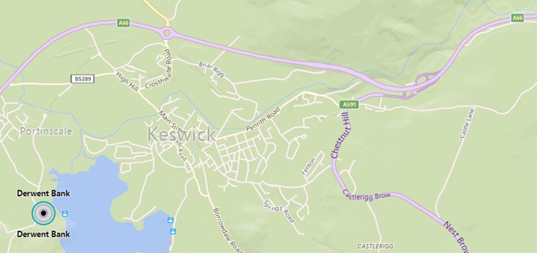
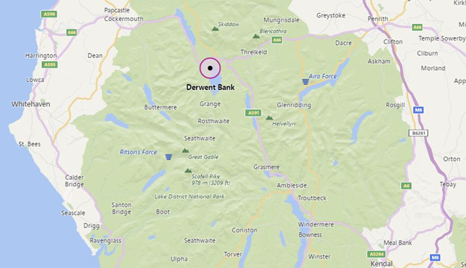

What to bring:
You MUST have:
- Walking boots
- A Water bottle (minimum 1 litre)
- A Rucksack with a plastic liner
- Waterproofs: jacket and trousers
- A Warm hat
- Warm gloves (not leather)
- Thick walking socks
- Base layer: (thin thermal or warm T-shirt. Best not to be cotton as it gets cold when wet)
- Over layer: (warm sweater or fleece)
- Extra layer: warm top for when cold (eg. when stopped for lunch)
- Comfortable walking trousers (not jeans as they are too cold & heavy when wet)
- Personal Medication
- Smart casual clothes for the evening.

You may wish to bring:
- Trekking Poles
- Vacuum flask (if you like hot drinks on the hill)
- Medium size Tupperware container or plastic bag, to put picnic lunch in.
- Sit mat
- Sun glasses
- Lip salve
- Camera
- Personal first aid kit

In good weather and/or summer, you may also wish to bring
- Short trousers
- T - Shirts
- Sun hat
- Sun tan lotion

In poor weather and/or winter, you may also wish to bring:
- Gaiters
- Balaclava
- Extra warm clothing

