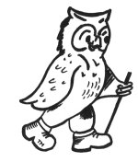
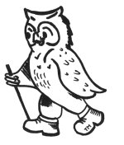
Walking Weekend Whitby Coast and Moors

Joining Instructions to Larpool Hall, Whitby

On behalf of all the WalkWise team, thank you for booking your walking event! The WalkWise guides will arrive early evening and are looking forward to meeting you.

- Arrival time: any time after 4:00 pm. There will be tea and biscuits available in the main lounge between 4.00-4.30pm. Should you wish to arrive any earlier please enquire at the centre directly.
- Arrival meal: is set for 7:00 pm. Meet in the bar from 6:30 pm when you will have the opportunity to meet your guides and they will discuss the overall event and walks.
(There is only one sitting for the evening meal as we are fitting in with other guests. The kitchen closes at 7.30 pm and if you going to arrive after that we would advise you to eat en-route. If you are going to be late for the arrival dinner please advise the hotel or leaders on the contact numbers below!)
- What to bring: To ensure that you are properly equipped, please take a moment to read through the ‘What to bring list’ and ensure that you have the necessary clothing and equipment.
- We recommended these maps for this event:
- Maps: The map for this event is: 1:25000: EX027: North Yorkshire Moors Eastern

HF Holiday’s, Larpool Hall, Larpool Lane, Whitby, North Yorkshire, YO22 4ND

Tel: +44 (0)1947 602737 Email: whitby@hfholidays.co.uk

Directions:

For Sat Nav. Enter the postcode YO22 4ND and Larpool Lane if required. Grid reference: NZ 899 093

By Car:

Most guests approach Whitby via the A171 from Teeside or the A169 from Malton and Pickering which joins the A171. After this roundabout and as you approach Whitby cross another roundabout then turn right at the traffic lights signposted to Scarborough. Cross the bridge over the River Esk then take the next right into Larpool Lane. Towards the top of the hill take the narrowing road on the left, following signs to Larpool Hall, which is directly ahead of you.

By Rail
The nearest railway station to Larpool Hall is Whitby. However, you may find that the journey to Scarborough station is more convenient. For train times and general rail enquiries call 08457 484950 (24hrs) or visit www.nationalrail. co.uk. If you are phoning from outside the UK call +44 (0) 20 7278 5240.

Station transfers by taxi
The 2 mile journey from Whitby takes approximately 10 minutes.
The hotel have negotiated a preferential rate with Harrisons Taxis for all pre-booked journeys of £5.80 per taxi. The 20 mile journey from Scarborough rail station takes approximately 40 minutes. The preferential rate with Harrisons Taxis is £28 per taxi. They will arrange shared taxis wherever possible. To book either transfer please call or email: George Harrison Whitby Ltd Tel: 01947 600606/600600 Email: kw3@btconnect.com George Harrison Whitby Ltd is not owned or managed by HF Holidays.
The return journey can be arranged on your behalf by the House Manager.

Station transfer by bus.
The 93 bus service runs twice an hour from Scarborough rail station to Whitby. As you approach Whitby, alight by the Larpool Industrial Estate. From there it is an 800m walk to Larpool Hall. Please contact Traveline on 0871 200 22 33 or visit www.traveline.info for details of bus times. Please contact Traveline on 0871 200 22 33 or visit www.traveline.info for details of bus times.

If you are having problems finding the centre, please call them directly, or you could call one of the WalkWise guides.
Andrew Casey: 0774 894 2263
Gideon: 0780 907 0257

Whilst every effort has been taken to ensure your trip is enjoyable, occasionally unforeseen difficulties may arise. Should you have any concerns please raise them with your guides at the time. They will then endeavour to resolve them swiftly so that you can enjoy your trip.
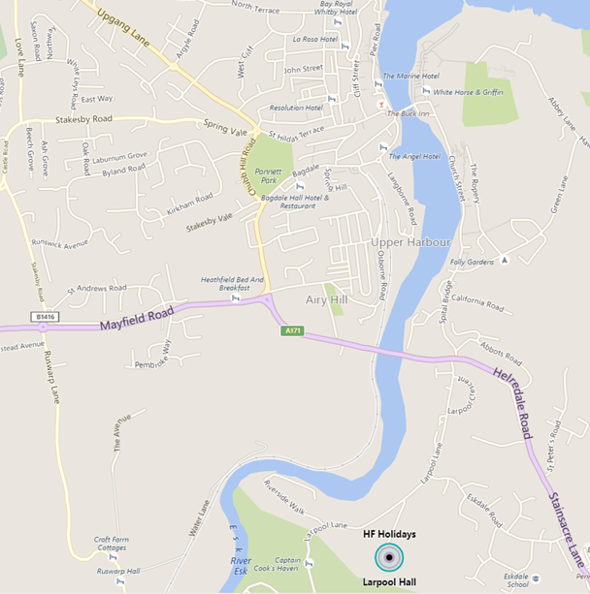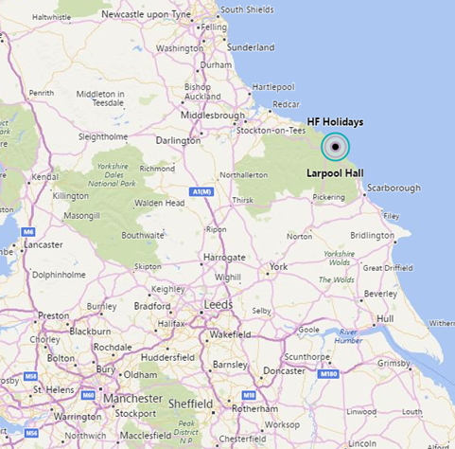

What to bring:
You MUST have:
- Walking boots
- A Water bottle (minimum 1 litre)
- A Rucksack with a plastic liner
- Waterproofs: jacket and trousers
- A Warm hat
- Warm gloves (not leather)
- Thick walking socks
- Base layer: (thin thermal or warm T-shirt. Best not to be cotton as it gets cold when wet)
- Over layer: (warm sweater or fleece)
- Extra layer: warm top for when cold (eg. when stopped for lunch)
- Comfortable walking trousers (not jeans as they are too cold & heavy when wet)
- Personal Medication
- Smart casual clothes for the evening.

You may wish to bring:
- Trekking Poles
- Vacuum flask (if you like hot drinks on the hill)
- Medium size Tupperware container or plastic bag, to put picnic lunch in.
- Sit mat
- Sun glasses
- Lip salve
- Camera
- Personal first aid kit

In good weather and/or summer, you may also wish to bring
- Short trousers
- T - Shirts
- Sun hat
- Sun tan lotion

In poor weather and/or winter, you may also wish to bring:
- Gaiters
- Balaclava
- Extra warm clothing

